Pages 77 -93 ***Java Programming A Comprehensive Introduction***

Page 893

What is the **if / else** ladder? – while the condition inside if statement is not correct, using “else” will execute the code inside the else statement.

What is a nested **if?** – for nested if, there should be at least two if statement in which, one if statement should be inside another if statement.

Information on “Whiteboarding”:

Video describing PseudoCode and White Boarding.

https://www.youtube.com/watch?v=4G0EYfrrDT8

Pseudocode- Pseudocode (pronounced SOO-doh-kohd) is a detailed yet readable description of what a computer program or algorithm must do, expressed in a formally-styled natural language rather than in a programming language.

What is “whiteboarding”? – White boarding is an outline of the code that we write before start wring program using compiler.

As a new programmer why is white boarding important? – White boarding helps to breakdown the ideas and step that are required to build a program.

Coding Thought Process:

* Variables needed (values)?
* Variables initialized
* Variables assigned value
* Code Blocks Needed (Structure)
* Control or Flow of Program (Design / Order)
* Code Blocks Created
* Data Structures needed (how will multiple values be stored / represented)?
* Data Structures initialized
* Data Structures assigned value

Provide 2 Online Links to resources you found on the internet to help you understand Pseudocode / “whiteboarding”.

**https://www.youtube.com/watch?v=vgkahOzFH2Q**

Paired Programming-

Why is paired programming used in industry?

Provide 2 Online Links to resources you found on the internet to help you understand Paired programming-

**Programming Assignments**

**Review Task:**

**Work with partner to share code. Make sure you have correct outcomes from the previous assignments.**

* **Please write the name of the person you compared code with.**

**The person name is - Besufekad Debebe**

* **Please note similarities and differences on how your partner solved problem.**

Task 1**-** Write a program that prompts a user to enter the points earned for a course and determines the grade based upon the following scale.

0 – 59 is a F **Print:** Try Harder

60 – 69 is a D **Print:** Try Harder

70 – 79 is a C **Print:** OK

80 – 89 is a B **Print:** Good

90 and greater is an A. **Print:** Excellent

Create a White Boarding Diagram of Code Before writing Source Code.

Use the **If / Else** ladder to create the source code.

Output grade received as well as statement associated with matching message.

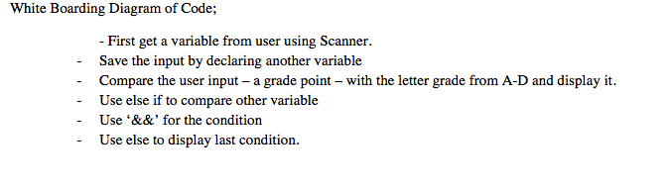

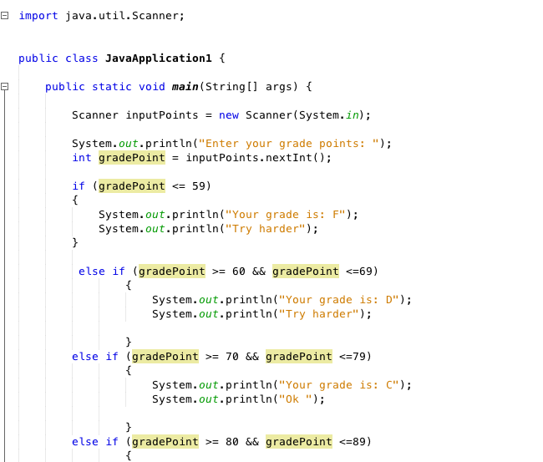

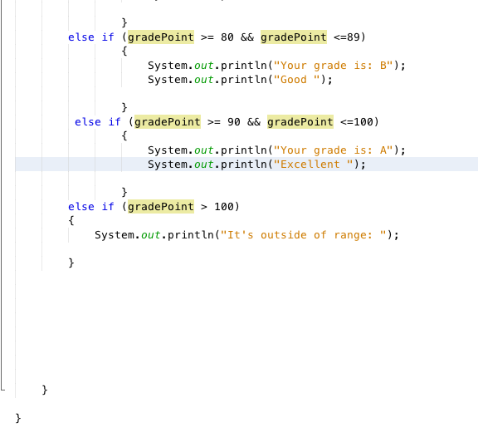

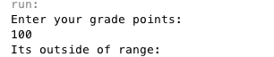



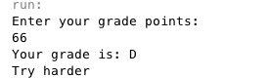

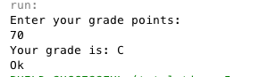

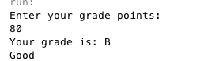

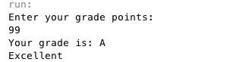

White Boarding Diagram of Code;

- First get a variable from user using Scanner.

* + Save the input by declaring another variable
  + Compare the user input – a grade point – with the letter grade from A-D and display it.
  + Use else if to compare other variable
  + Use ‘&&’ for the condition
  + Use else to display last condition.